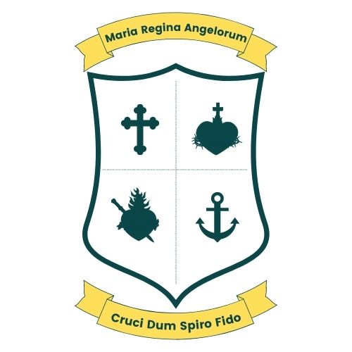
Scoil Bhríde, Loreto National School
Scartlea,Muckross,Killarney,Co Kerry.
Tel; 064 6632484 E-mail; office@loretonskillarney.com

Rationale:
In the interest of providing the best possible education for all pupils, it may, from time to time, be necessary to divide and combine class groups into mixed classes. These smaller groupings can offer a more favourable pupil–teacher ratio. Currently, there are five class teachers and eight class groupings in Scoil Bhríde, Loreto National School; therefore, the formation of split classes is an inevitable occurrence at certain stages.
Aims and Objectives of this policy:
• To provide a framework for the splitting of classes
• To outline the criteria for placing children in particular split class groupings
• To set out the supports which may be used to ensure the best learning outcomes for all children in split classes

Framework for the splitting of classes:
At the time of planning the classes for the coming year, the Principal will look at the overall numbers in each year group, the number of teachers and space available to teach them. He will decide how best to organise classes with a view to providing the best educational opportunities for all children.
• The arrangement of classes will differ from year to year; in some cases there may be no need to split any class in an academic year. A class split is put in place for one school year, numbers and staffing arrangements will dictate the arrangement in subsequent years. In short, a class may be split once, more than once during their time in primary school or perhaps not at all. These arrangements are made year to year.
• Classes which have been split reunite daily to play together on yard so they can maintain existing friendships as well as make new friendships in their grouping. This increases their circle of friends and their abilities to form new friendships. As far as possible, certain lessons, activities and trips etc for the split class are planned throughout the year to allow them to work together as a group.
Criteria for placing children in particular class groups:
When dividing a class into groups, to be placed in separate classes, there are certain criteria to be taken into consideration:
- The process of forming new friendships is a life skill which is important to develop. A positive and supportive attitude from parents is a key element in achieving a successful outcome in the new groups.
- Classes will be split in an open and transparent manner.
- A class will be split on the basis of the oldest boy and then the oldest girl being selected until the required number of pupils in each room has reached an equitable spread of pupils between the relevant teachers.
- The above criteria will serve as the primary basis for dividing classes. However, alternative criteria may be applied where necessary to ensure a balanced gender distribution within each classroom.
- Parents of twins and siblings will be given the option of splitting their children or keeping them in the same group.
- Class divisions will be made known to parents and pupils before the summer holidays.
- The division of classes by date of birth will be carried out by the Principal and witnessed by the Chairperson of the Board of Management and a representative of the Parents’ Association.
- Children with Special Educational Needs and/or children experiencing significant personal, family, social or emotional circumstances may be allocated to class groupings at the discretion of the Board of Management, in consultation with parents/guardians, teachers, and relevant support staff, where appropriate
The supports which could be made available to children and teachers in split classes.
The Principal, the class teacher and special education team will consult on how best to organise the support teaching for the mixed class. In some cases, the special education teacher may work in the classroom with the class teacher, in a team teaching arrangement. It is possible that the special education teacher may work in the classroom supporting a small group of children, with the class teacher doing the main teaching of the lesson. Another arrangement for support teaching which may suit the class is for either the class teacher or the special education teacher to withdraw small groups of children. All of these arrangements must be considered on a class by class basis, from year to year.

This policy was ratified at a Board of Management meeting held on 7th May 2026.

