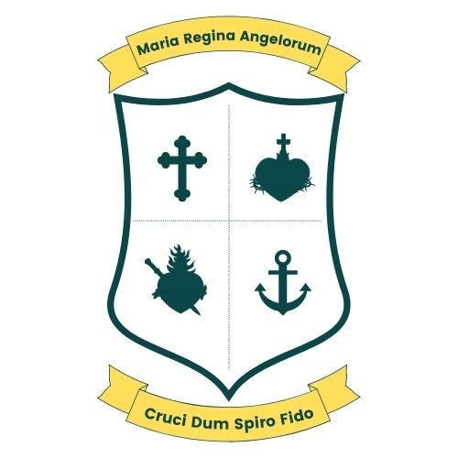
Scoil Bhríde, Loreto National School
Scartlea,Muckross,Killarney,Co Kerry.
Tel; 064 6632484 E-mail; office@loretonskillarney.com

4th Class Booklist 2026/27
The following books will be provided by the school free of charge;
English
Lift Off textbook (CJ Fallon)
Master You English 3 (CJ Fallon)
Spellings for Me
Read at Home 4 (CJ Fallon)
New Wave handwriting 4th (Prim-ed)
Reading Pack
Class Novel

Gaeilge
Bua na Cainte 3 (Edco)
Am Don Léamh 4 (Folens)
Léigh sa Bhaile C (CJ Fallon)
(Soilse Ar Ais Arís) – Leabhar 1 – Realtaí (CJ Fallon)

Maths
Maths My Way 4th class (Folens)
My Maths Practice 4th class (Folens)

S.P.H.E
Let’s Do This (Stage 3)

S.E.S.E
Small World 4 (Geography, History & Science) (CJ Fallon)
Let’s Discover 4 (Geography, History & Science) (CJ Fallon)
Atlas

Music
The Right Note (Folens)

Religion
Grow in Love

Copies
Pack of 5 (120 pages)
2 Maths copies (120 pages)
2 Project copies (40 pages)
2 hardback A5 notebooks

Items to be purchased by parents;
Homework Journal
Tin Whistle D
Mathematical Set
Calculator
2 Black sharpies
3 Blue/red Biros, 3 HB pencils, 30cm ruler, sharpener, eraser
Colouring pencils or twistables or markers
Pack of whiteboard markers
Mesh Wallet (pack of 3) to fit A4 size
2 Glue sticks
English dictionary
Foclóir (English/Irish – Irish/English)
A4 pocket display folder (80 pages)
Please label all items: books, stationary, school uniform, jackets, bottles and lunch boxes.

Please label all stationery

