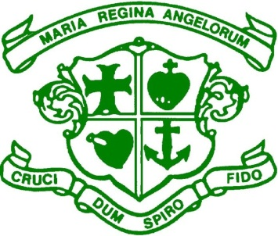
Scoil Bhríde, Loreto National School
Scartlea, Muckross, Killarney, Co Kerry. V93 AY90
Tel: 064.6632484 E-mail: office@loretonskillarney.com
www.loretonskillarney.com

ANNUAL ADMISSION NOTICE
In respect of admissions to the 2026/2027 school year

Admission Policy and Application Form
A copy of the school’s Admission Policy and the Application Form for Admission for the 2026/2027 school year is available as follows:–
To download at: www.loretonskillarney.com
On request: By emailing: office@loretonskillarney.com
Or writing to: Scoil Bhríde, Loreto N.S., Scartlea, Muckross, Killarney, Co. Kerry.

Application and Decision Dates for admission to 2026/2027 school year;
The following are the dates applicable for admission to Junior Infants.

The school will commence accepting applications for admission on: | Monday,13th October 2025
The school shall cease accepting applications for admission on: | Friday,  30thJanuary 2026
The date by which applicants will be notified of the decision on their application is : | Friday,  13thFebruary  2026
The period within which applicants must confirm acceptance of an offer of admission is: | Friday,6th March 2026
*Failure to accept an offer within the prescribed period above may result in the offer being withdrawn.
Note: the school will consider and issue decisions on late applications in accordance with the school’s admission policy.

Number of places being made available in Scoil Bhríde, Loreto National School

The number of places being made available in junior infants is | 25

