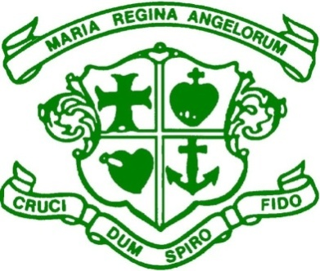
Scoil Bhríde, Loreto National School
Scartlea,Muckross, Killarney,Co Kerry.
Tel; 064 6632484 E-mail; office@loretonskillarney.com

Enrolment Application Form 2024/2025

Pupil’s First Name: _________________________ Surname: _________________________

Date of Birth: _________________________ Gender: _________________________

Address (at which the applicant resides): _____________________________________________ ________________________________________________________________________

Name and class of Sibling(s) currently enrolled:_________________________________________

_______________________________________________________________________________

Parish in which the applicant resides: _________________________________________________

Parent(s)/Guardian(s) Details:

Name: _______________________________________ [ ] Parent [ ] Custodian [ ] Legal Guardian
Address: _________________________________________________________________________

_________________________________________________________________________________

Home Tel. __________________ Mobile __________________ Email. _______________________

Name: _______________________________________ [ ] Parent [ ] Custodian [ ] Legal Guardian
Address: _________________________________________________________________________

_________________________________________________________________________________

Home Tel. __________________ Mobile __________________ Email. ________________________

Signature 1: _________________________ Signature 2: _________________________

Date: _________________ Date: _________________

Completed enrolment applications must be returned to Scoil Bhríde, Loreto N.S no later than 3pm on Friday,16th February 2024.

