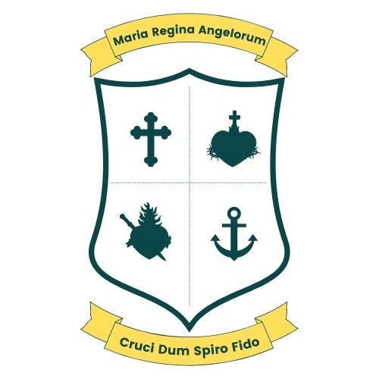
Scoil Bhríde, Loreto National School
Scartlea,Muckross,Killarney,Co Kerry.
Tel; 064 6632484 E-mail; office@loretonskillarney.com

6th Class Booklist 2026/27
The following books will be provided by the school free of charge;
English
Flying High
Master Your English
Read at Home
Spellings For Me
Folens Reading Pack

Novels
-There’s a Boy in the Girl’s Bathroom.
- Holes

Gaeilge
Caint is comhrá
Lasracha

Maths
Maths My Way
My Maths Practice

S.P.H.E
Mindful Matters

S.E.S.E
Let’s Discover
-History
-Geography
-Science
Atlas

Music
The Right Note

Religion
Grow in love

Copies
2 A4 Project Maths Copies 120 pg
8 A4 1Manuscript soft copies20 pg
1 A4 Hardback copy 120 pg

Items to be purchased by parents;
- 1 x 80 pg display folder
- 2 x HB pencils
- 2 x red pens
- 2 x blue pens
- 1 x Eraser
- 1 x Sharpener
- 1 x 30cm ruler
- 2 x gluestick
- 1 x Geometry set
- 1 x Pack of Colouring pencils
- 1 x Homework Journal
- Tin Whistle Key of D

Please label all stationery

