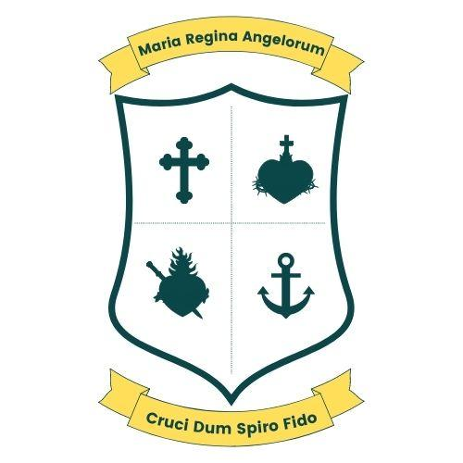

Senior Infant Booklist 2026/27
The following books will be provided by the school free of charge;
English
Move Write B Print Edition
Sounds Make Words Senior Infants
Rainy Days Senior Infants

Maths
Maths My Way Senior Infants Pack

Religion
Grow in Love Senior Infants

Copies
2 x A4 Scrapbooks
2 x Learn to Write Junior Copies
1 x Project Copy 15A

Other Programmes provided by the school

Decodable Readers, CJ Fallon (Rainbow) oral language response book, Jolly phonics Programme, Bua na Cainte, Nursery Rhyme Workbook.

Items to be purchased by parents;
A4 mesh zip wallet folder x 1 (hard wearing)
• Colours (twistables or colouring pencils- no markers)
• 3 triangular shaped pencils
• Pencil sharpener for large pencils
• Eraser • 3 large glue sticks
• 4 pack of dry erase white board markers -for the mini white boards
• 4 tubs of playdoh (Playdoh brand is the best quality)
Other Materials: School bag-big enough to hold A4 workbooks.
Child friendly lunch box and drink container.
Velcro shoes please-no laces
A spare pair of underwear, generic tracksuit bottoms/leggings/trousers and socks to be placed in a separate bag (clearly named on the outside) in case there are any accidents. (To be kept in school for the year)
Please label all items: books, copies, stationary, school jumpers, bottles and lunch boxes.

