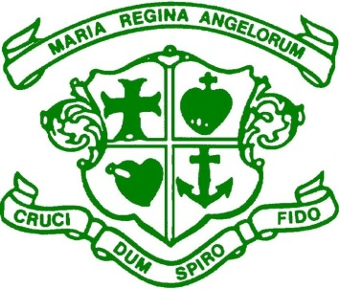
Scoil Bhríde, Loreto National School
Scartlea, Muckross, Killarney, Co Kerry. V93 AY90
Tel: 064.6632484 E-mail: office@loretonskillarney.com
www.loretonskillarney.com

ANNUAL ADMISSION NOTICE

In respect of admissions to the 2024/2025 school year

Admission Policy and Application Form
A copy of the school’s Admission Policy and the Application Form for Admission for the 2024/2025 is available as follows:–
To download at: www.loretonskillarney.com
On request: By emailing: office@loretonskillarney.com
Or writing to: Scoil Bhríde, Loreto N.S., Scartlea, Muckross, Killarney, Co. Kerry.

Admissions to the 2024/2025 school year

Application and Decision Dates for admission to 2023/2024 school year
The following are the dates applicable for admission to Junior Infants.

The school will commence accepting applications for admission on: | Monday,16th October 2023
The school shall cease accepting applications for admission on: | Friday,16th February 2024
The date by which applicants will be notified of the decision on their application is : | Friday,  1st March 2024
The period within which applicants must confirm acceptance of an offer of admission is: | Friday,15th March 2024
*Failure to accept an offer within the prescribed period above may result in the offer being withdrawn.
Note: the school will consider and issue decisions on late applications in accordance with the school’s admission policy.

Number of places being made available in Scoil Bhríde, Loreto National School

The number of places being made available in junior infants is | 25

