
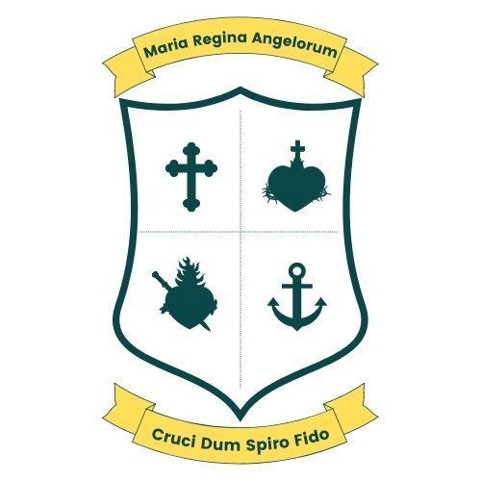

SUSTAINABILITY POLICY STATEMENT
All public service bodies are required under the Climate Action Plan to adhere to the Public Service Climate Action Mandate and to develop Climate Action Roadmaps setting out how they will deliver on their energy efficiency and emission reduction targets.
Schools now have a separate Climate Action Mandate under which they are required to adopt a Sustainability Policy Statement. The School Sector Climate Action Mandate can be read in full at: gov.ie – School Sector Climate Action Mandate.
The second National Strategy on Education for Sustainable Development (ESD to 2030) also informs the content of this Sustainability Policy Statement.
ESD aims to ensure that “by 2030, all learners acquire knowledge and skills needed to promote sustainable development, including, among others, through education for sustainable development and sustainable lifestyles, human rights, gender equality, promotion of a culture of peace and non-violence, global citizenship, and appreciation of cultural diversity and of culture’s contribution to sustainable development” (Sustainable Development Goal 4.7).
The following has been prepared as part of the School Sector Climate Action Mandate, in keeping with the principles and themes of ESD to 2030, and has been accepted by the Board of Management of our school.
PURPOSE
The purpose of this Policy is to outline how our school promotes sustainability and climate action through our daily actions and activities. Sustainability can be defined as the ability to exist and develop without depleting natural resources for the future, and where possible, improving or rejuvenating resources or systems.
SCOPE
Sustainability is a community issue and applies to all students, teachers, and employees of our school. Parents and guardians should note, and where possible promote, the Statement. The Board of Management will ensure that decisions made in respect of the school align with the Statement.
VISION, MISSION AND VALUES
Vision Statement:
We aim to develop a competent, happy individual, with a view to fully realising his/her potential as a moral, well-adjusted person who can maximise his/her talents.
Mission Statement:
We strive to enable children to become responsible and productive citizens and to develop the skills to embrace lifelong learning.
Our vision and mission align with the principles of sustainability—socially, environmentally, and economically. To realise their full potential, pupils must be supported to live well now and into the future, understanding that they are members of local and global communities and part of their environment.
WHOLE SCHOOL APPROACH TO SUSTAINABILITY
• Our school has adopted this Sustainability Policy Statement. It clearly details the aims and objectives of Education for Sustainable Development (ESD) in our school and its relationship to the vision and mission of the school.
• Our school recognises ESD as a cross-curricular theme, coordinated effectively across the school. Sustainability topics are explicitly outlined in the SESE Plean Scoile.
• Opportunities are identified to introduce and address sustainability across all subjects. Teachers are encouraged to incorporate at least one sustainability theme in their yearly plans.
• We endeavour to align all school policies with the principles of sustainable development.
• Resources to assist in the teaching of sustainability are sufficient and reviewed regularly.
• Our school is a member of the Irish Schools Sustainability Network (ISSN).
• Our school keeps up to date with developments in ESD, including registration for the quarterly ESD Newsletter.
ENVIRONMENTAL SUSTAINABILITY
Green-Schools is an international environmental education programme that supports schools in applying environmental learning to everyday practice.
• Our school engages with SEAI Education & Youth Programme resources, pupil workshops, and teacher CPD.
• Our school uses SEAI Energy in Education resources and tools to monitor and report energy consumption.
• Our school engages with ISSN initiatives such as the Climate and Nature Summit and Bitesize Biodiversity.
• We promote recycling and use recycled/recyclable materials where possible.
• Resources are procured with environmental impact in mind (e.g., compostable trays).
• Sustainability information is clearly displayed throughout the school.
• We promote care and responsibility for the natural environment.
• Outdoor learning is encouraged. We are developing an outdoor classroom and already have sensory planting, a tree area, and a vegetable patch.
• Biodiversity is supported (e.g., pocket forests, reduced grass cutting, no herbicides/pesticides).
• Sustainable transport is promoted, including walking and cycling. Bicycle racks are installed and communication with parents supports safe practices.
• Our school engages with programmes supporting environmental education (e.g., ECO UNESCO).
SOCIAL SUSTAINABILITY
• Our school ethos recognises and is sensitive to gender equity.
• Students are given opportunities to develop skills to solve local community problems.
• We prepare students for life as global citizens.
• The needs of all students, including those with differing abilities, are accommodated.
ECONOMIC SUSTAINABILITY
• A non-competitive ethos of cooperation and resource sharing is promoted.
• Students are involved in decision-making (e.g., Student Council).
• Fundraising reflects ethical and sustainable principles.
• School buildings are maintained to a high standard with sustainability in mind.
• Circular economy principles are promoted (e.g., used uniform distribution).
CULTURAL SUSTAINABILITY
• We foster self-esteem, mutual respect, and positive relationships.
• Students are prepared for life in a multicultural society.
• Community engagement is encouraged through partnerships.
• Cultural diversity is actively supported within the school and wider community.
TEACHER COMPETENCE
• Teachers are supported in building capacity in ESD through CPD and ISSN engagement.
STUDENT COMPETENCE
• Students are encouraged to participate in peer learning.
• Student Council, Active Schools Committee, and Green Schools Team contribute to decision-making.
• Students are encouraged to engage in community sustainability initiatives.
• Project-based learning linked to real-life local issues is promoted.

GOALS
Scoil Bhríde, Loreto National School aims to develop an outdoor classroom space, including seating, sensory planting, and displays, by the end of the 2026/2027 school year.
IMPLEMENTATION AND REVIEW
This Statement was implemented on 07/04/2026. It will be reviewed annually to ensure continuous improvement in sustainability and climate action.

www.loretonskillarney.com

